6. Create & Open HTML Pages:

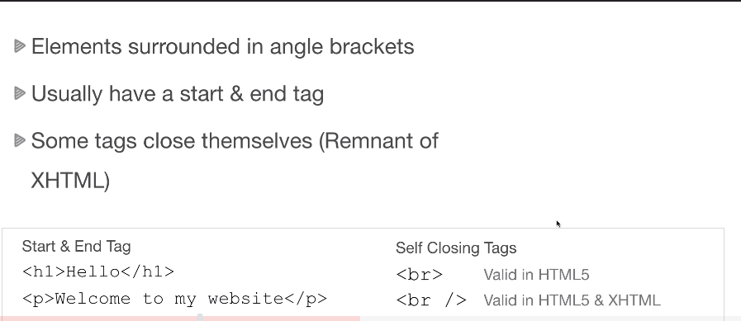

9. Meta Tags & Search Engines:

<meta charset="UTF-8"> :  which is the character set, and this specifies the character encoding of the page. So UTF 8 is actually the default. It's the character encoding for Unicode.

<meta name="viewport" content="width=device-width, initial-scale=1.0"> :

This is pretty important for Responsive design. This is the viewport tag and responsive design it. It's all about making your website or your user interface responsive to different screen sizes.

So, if you've ever gone on a nonresponsive site on a smartphone and you had to drag your finger over to kind of see the rest of the site that probably doesn't have the viewport set OK, so you wanted to. actually, show the entire Web site or the entire interface. So that's what the viewport tag does it's actually really important.

16. HTML Entities:

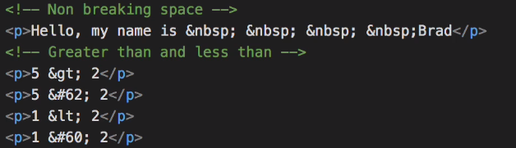

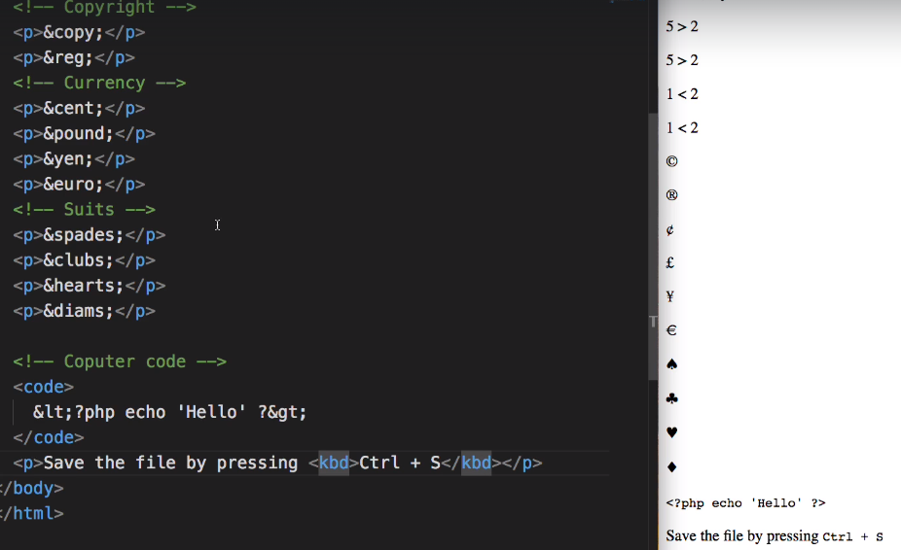

17. Block & Inline level elements :

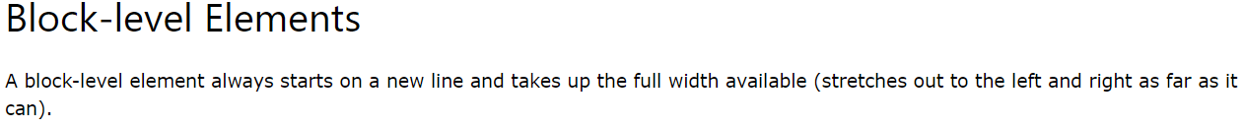

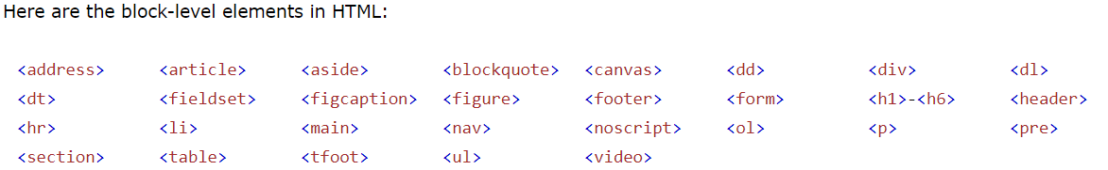

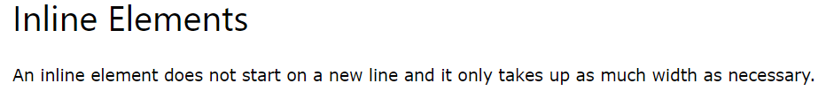

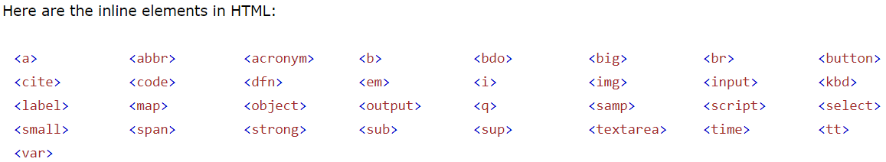

17. HTML Semantic tags:

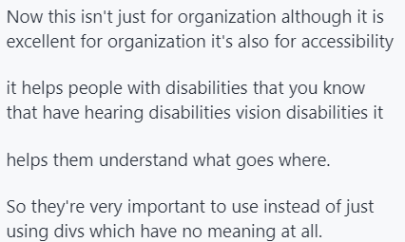

Few more popular HTML tags:

